Membership Affiliation Tutorial

Remember, you must have 5 registered members to start a chapter. If you have any trouble registering members during this process feel free to reach out to Delaware HOSA.

Note: It is recommended that your chapter secretary handle your chapter’s affiliation. Before completing each round of affiliation it is recommended that as the advisor you verify and be the one to click “Done.”

- Go to www.hosa.org

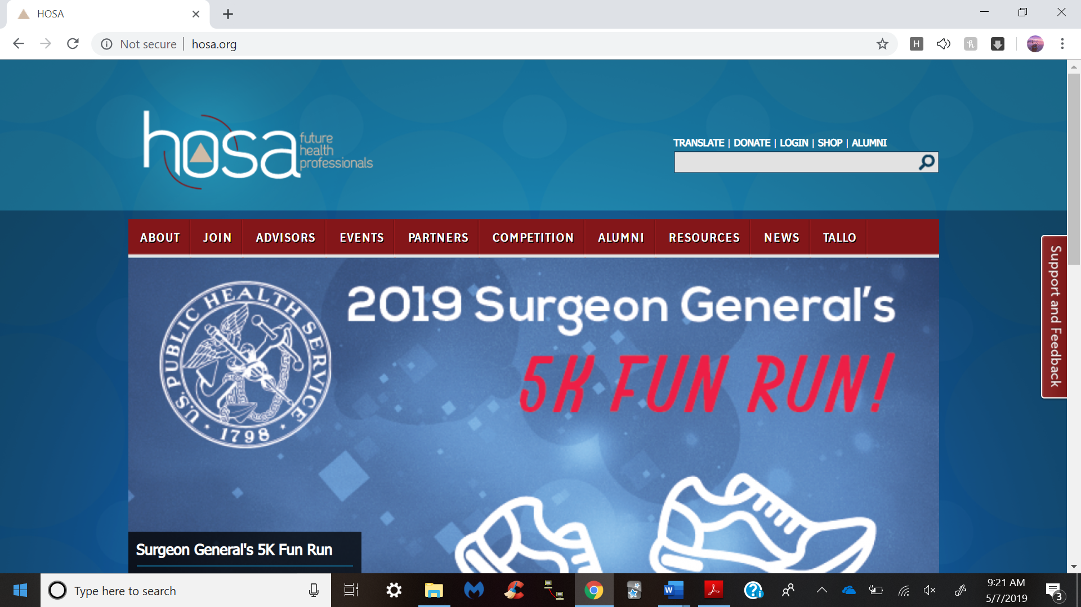

- Click on “Login” at the top of the page.

- Click on “Access Chapter Advisor Services” under Local Chapter Advisors. This will take you to the HOSA Conference Management System where you will type in your Charter Number and Password.

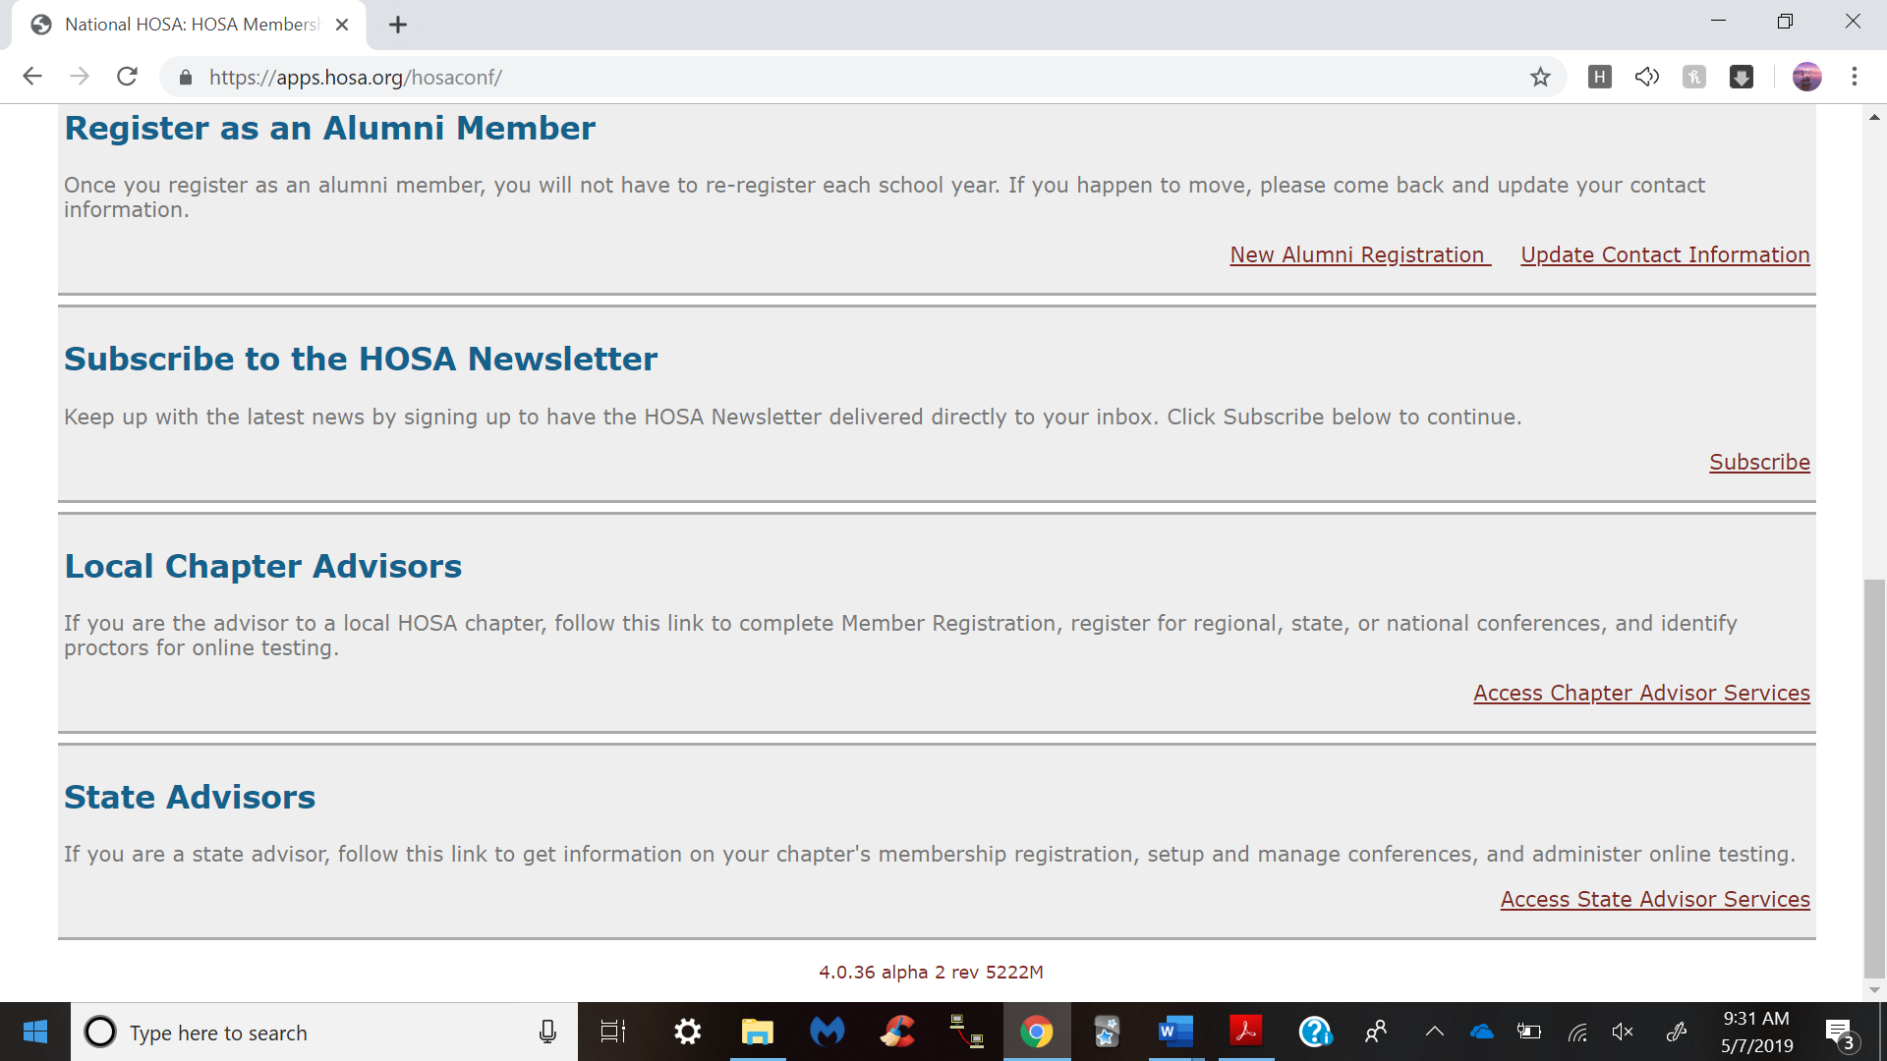

- Delaware HOSA provides this number to you from International HOSA upon starting a chapter. At this time, you will type in your charter number and password, and then click “Login.” The password is case sensitive. If you have trouble accessing your account, feel free to reach out to us. We have a list of all charter numbers and passwords and are more than willing to provide again if you accidently misplace yours or have trouble logging in.

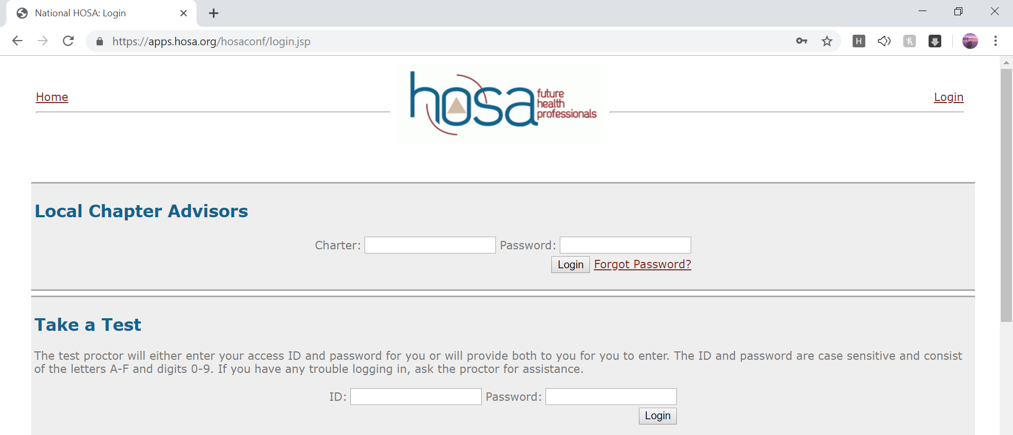
- A screen will appear that has a Chapter Affiliation section. You will click on “Complete the Affiliation Application.”

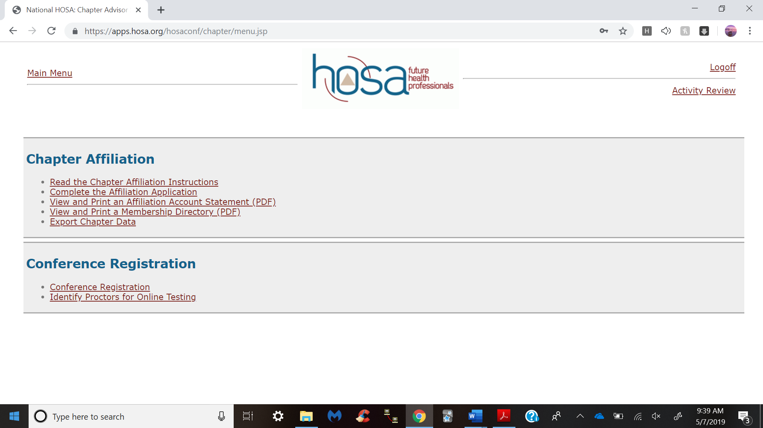

- This screen outlines basic directions about the system. After reading these instructions, click “Next.”

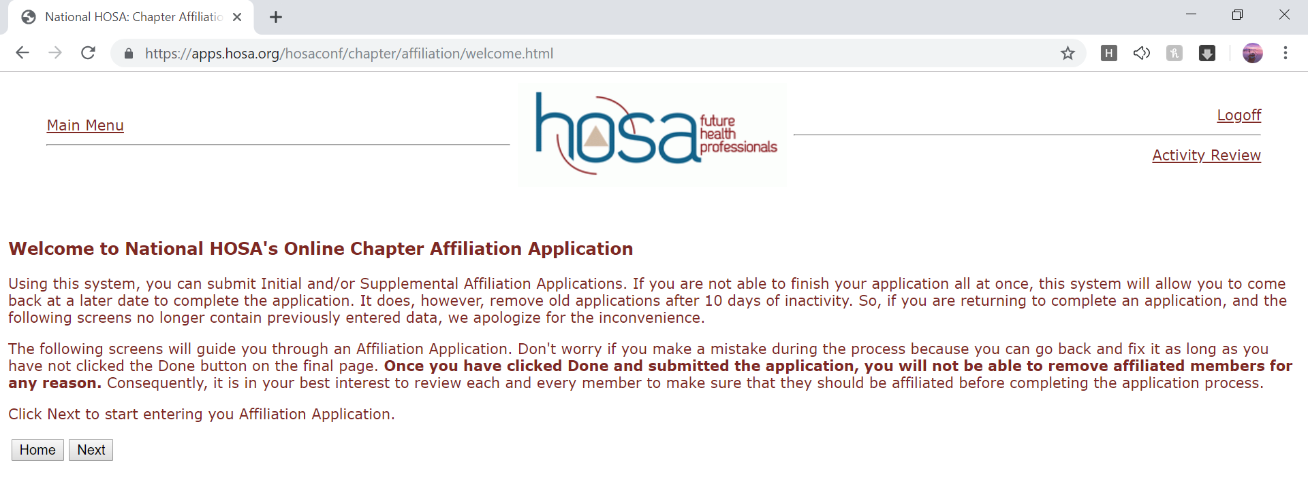

- All your basic information should be listed. If you are a new advisor or your name is not listed, make sure to edit this. After confirming the information click the “Next” button.

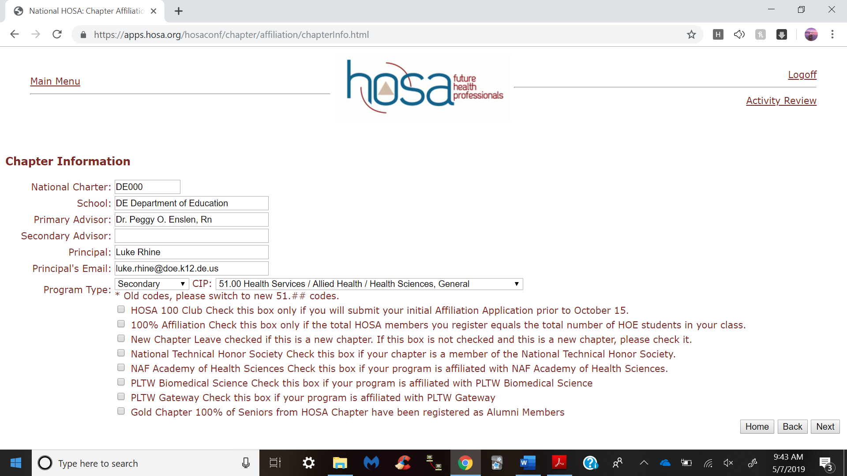

- Make sure this information is correct, as this is how International HOSA will bill membership. After confirming the information click the “Next” button.

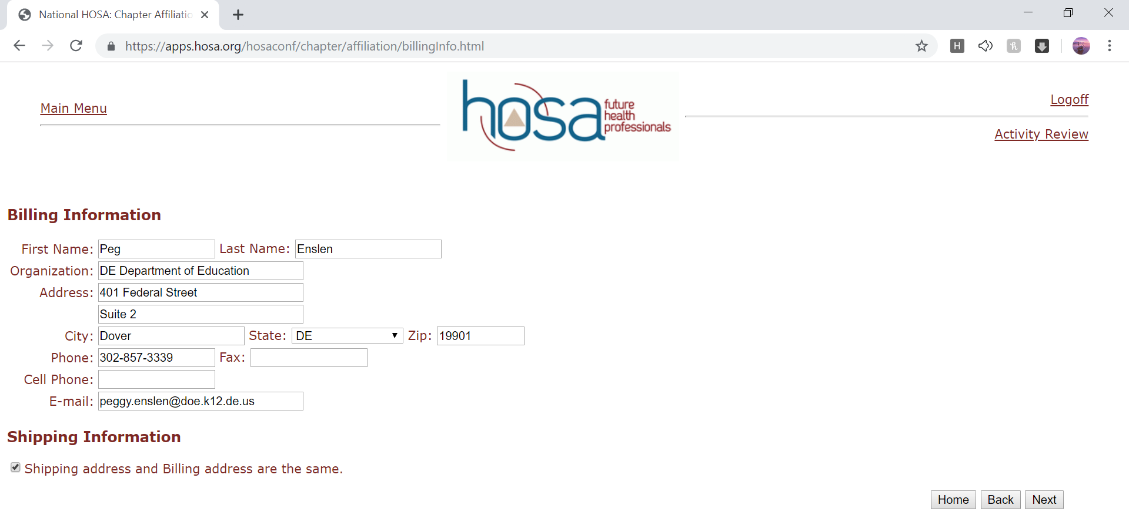

- It is important to know the makeup of our membership so that the organization may be eligible for certain grants. If you prefer, you can come back later and edit your Chapter Demographics. Click “Next.”

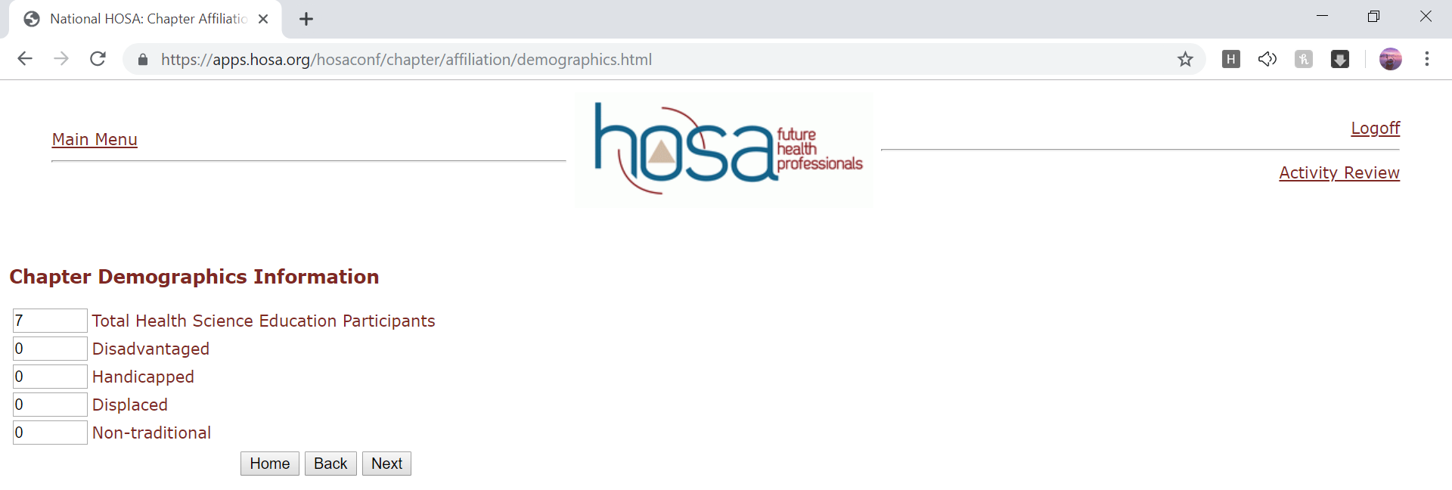

- This is the screen in which you will add new members. The only information that you need to put in is the classification, member type, first name, and last name. It is crucial that you spell their name correctly in this screen, as this is how the name will appear everywhere else throughout (i.e. on screen if they are recognized at a conference, on their name badge for conference, etc.). Please use upper/lower case like the example. If you have the cell phone and email you can add that too; however, the name and classification is mandatory. Once you have typed in this information you will click “Add Member (+).”

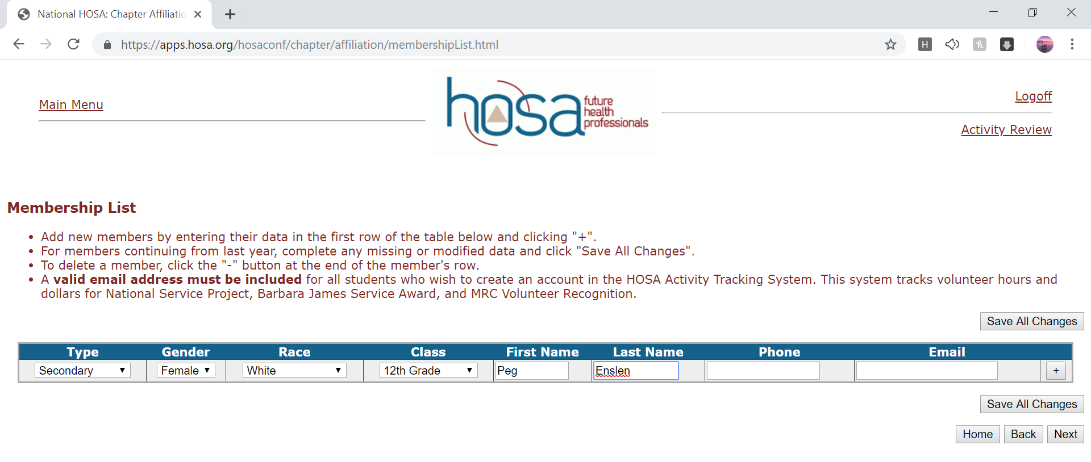

- If you accidently add the same person twice or make a mistake in spelling you can delete the selected member by clicking the “-“ symbol on the right hand side or edit the selected members information by clicking on their name. Once you have entered all members, click “save changes” and then “next.”

- This next screen will post a total number of members and the amount due for affiliation dues. The total amount due will need to be sent to International HOSA in Texas. Delaware HOSA does not collect membership dues from schools. Once affiliation is submitting, you are committed to the agreement to pay the invoiced amount. No refunds will be given after submission. Click the “Next” button after verifying this information is correct.

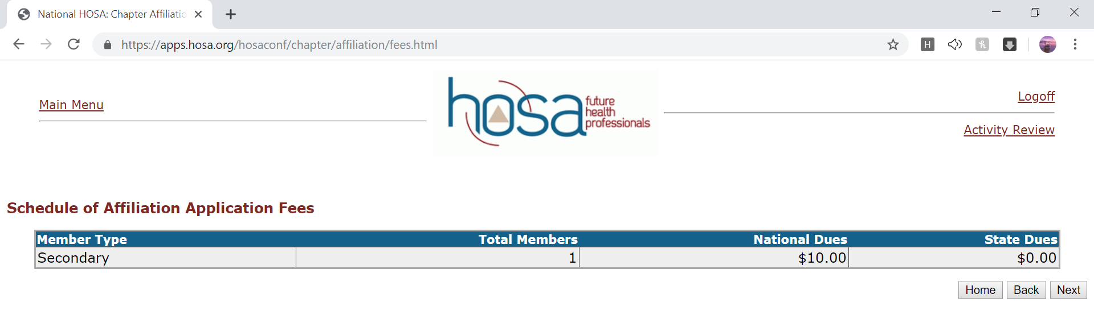
- After reviewing the agreement you will scroll down and click “Done” in the bottom right corner of the page. Now the new members are in the system. If you would like to view your membership directory go to the “Home” section of the website. You can follow this process each time you want to add members. You can add as few or as many as you would like each time and you can complete the affiliation process as many times as you would like throughout the year.

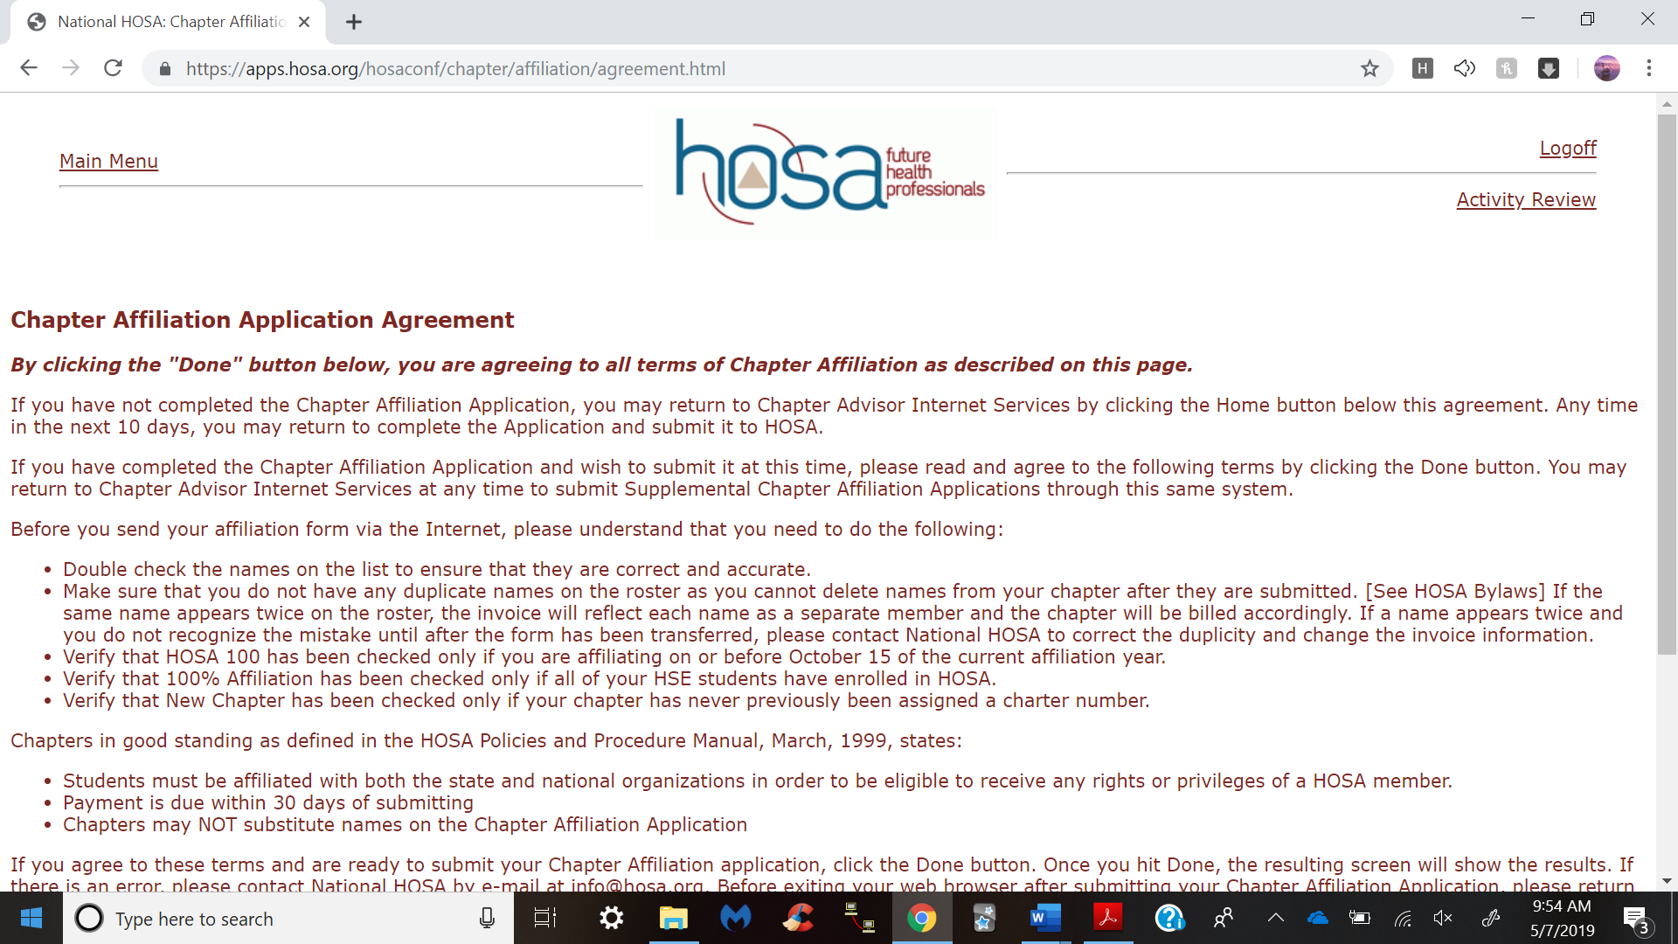

- Once you select “Done” you will see the following screen. Under Chapter Affiliation you can click “View and Print Membership Directory.”

- If you followed the steps exactly you should see the members that have been added.

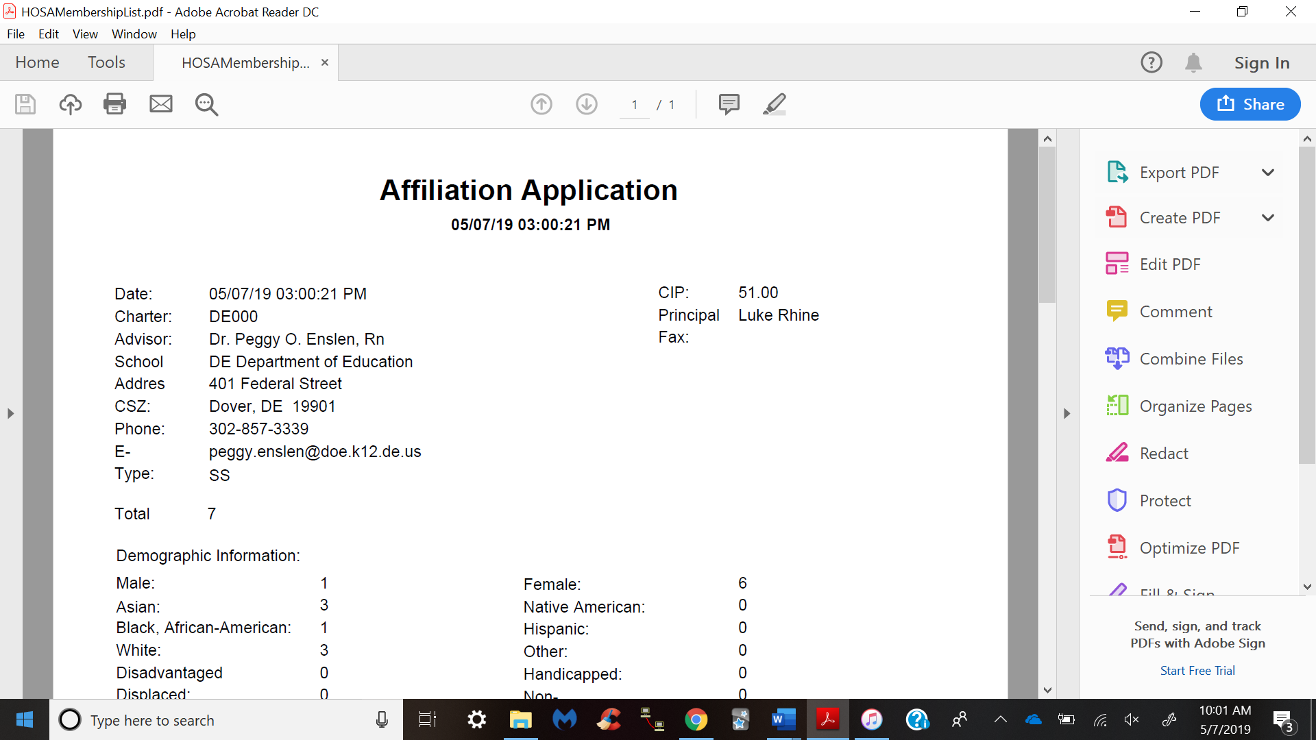

Congratulations! You now know how to register students as members! Remember there is no deadline for registering students as members. However, a student or advisor has to be a member of HOSA to attend any conference.

