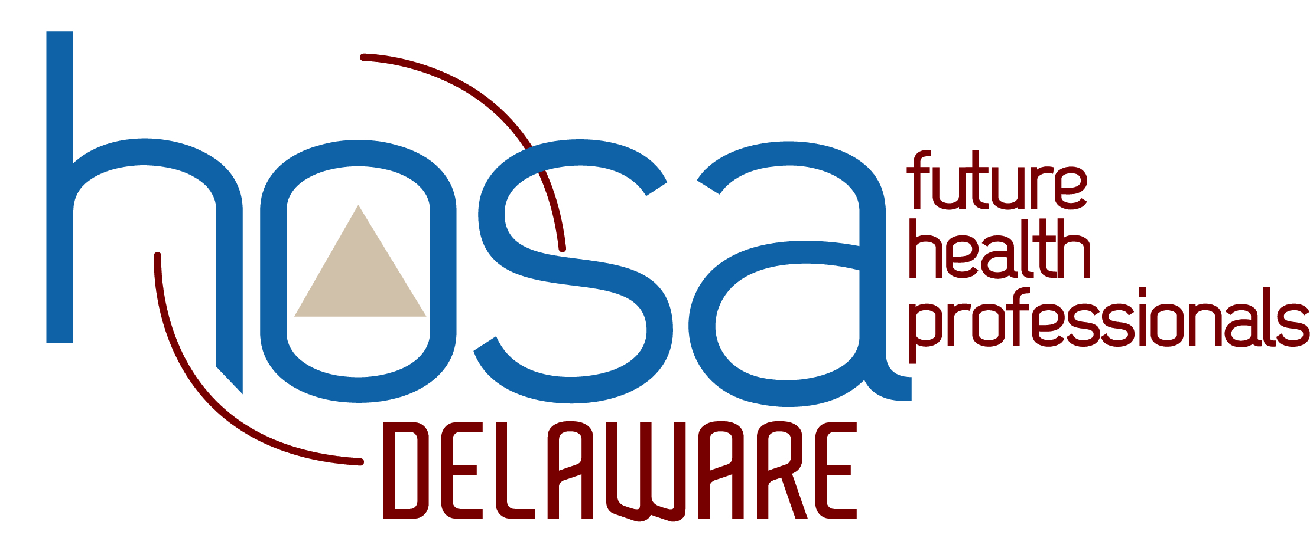
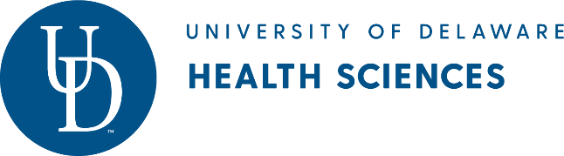
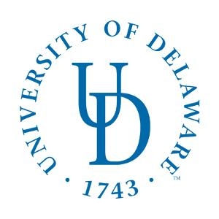
Delaware HOSA-Future Health Professionals
2019 State Leadership Conference
Advisor Registration

I certify that the following forms have been completed for each student attending the 2019 HOSA- Future Health Professionals State Leadership Conference held at the University of Delaware STAR campus on April 2-4, 2019.

- Permission and Medical/Emergency Treatment

- Authorization for Photo Release
(Please list the student(s) name(s) below where
permission has not been granted)

- Advisor Background Check Verification

Advisor School

Advisor School

Advisor School

Advisor School

The parent(s)/guardian(s) of the student(s) listed do not grant permission to the
Delaware Department of Education to use their child’s picture for publication.

Any pre-existing medical conditions need to be brought to the HOSA State Advisor or Program Manager’s attention prior to the State Leadership Conference.

Advisors should retain original permission slips, medical forms and the UD Photo Release Form.
Advisors are required to submit the Advisor Background Check Verification form
at registration

