Delaware HOSA 2017-20187 T-Shirt and Pin Design

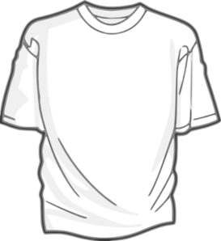
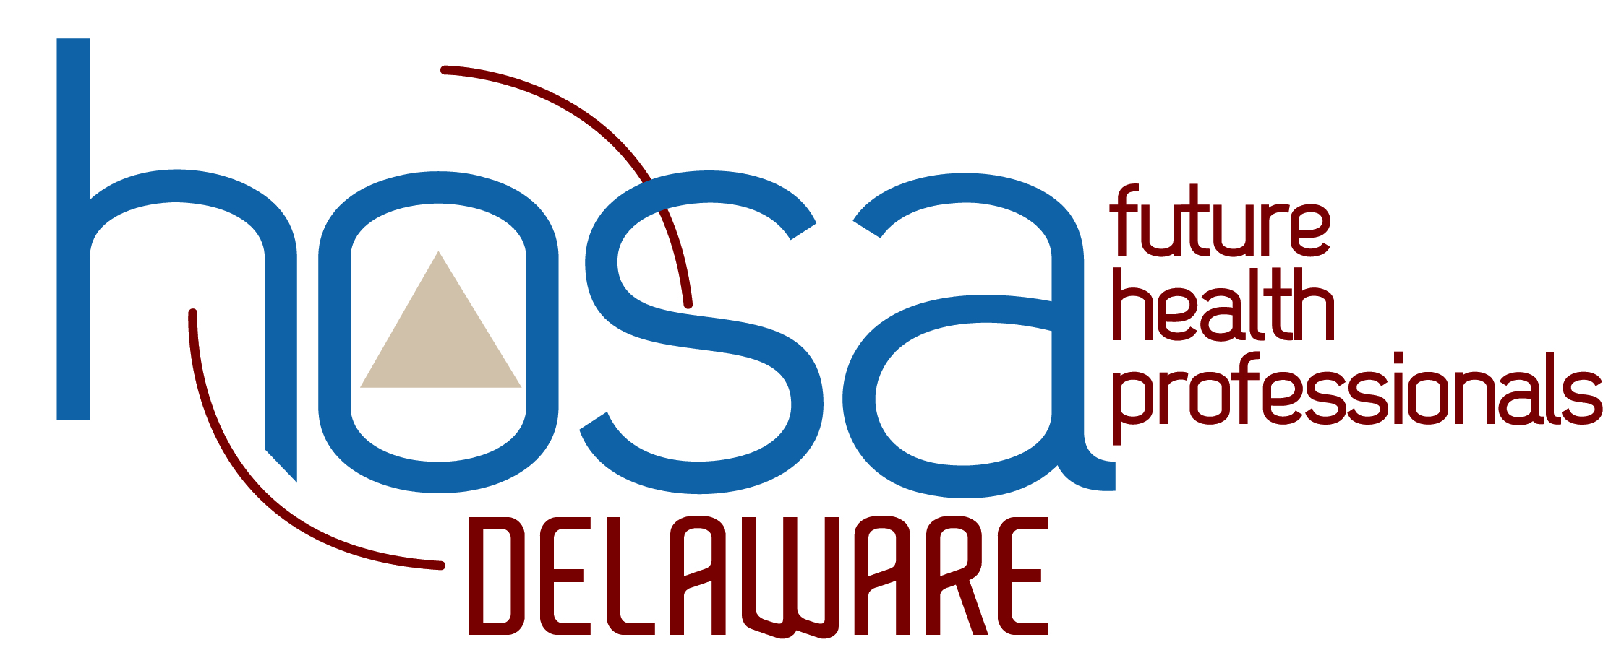
Delaware HOSA students are encouraged to submit a T-Shirt OR Pin design for the 2018 HOSA State Leadership Conference. Students who submit designs will be permitted to participate in another competitive event. This is not a nationally recognized event.

The Delaware HOSA Management Team and State Officers will review submissions, and the first place designs will be used to create the Delaware t-shirt and pin for the 2018 HOSA International Leadership Conference in Dallas, TX.

Guidelines
- Submissions will only be accepted from December 1, 2016 12:00 PM (EST) to February 10, 2017 11:59 PM (EST).
- Student must submit entry to a school HOSA Advisors. Students should not submit directly to Delaware HOSA. Each school can submit four (4) pin and four (4) t-shirt designs. Students selected in the “top four (4)” for their school can register in Delaware STEM Premier and upload their design.
- Submit one design per person; choose either t-shirt or pin. If you submit more than one, only your first submission in order of date and time will be considered.
- You must be a current registered member of HOSA for your submission to be considered.
- The design must include the words “Delaware” and “HOSA.”
- Submit only original designs. These designs must not contain copyrighted material and they cannot have previously won any awards.
- Submit front t-shirt designs only. There should be no text or visuals on the back of the shirt.
- Please limit design to two colors.
- Attach entries as medium resolution JPEG or pdf files.
- You must be prepared to submit the original Illustrator or Adobe Photoshop file in the event your artwork is chosen.
- Please note that due to production restrictions, the winning design may be altered.
- Any artwork and writing submitted will not be returned, and becomes property of Delaware HOSA.
- Top three designs for both t-shirt and pin submissions will be notified by email and invited to attend the final day of the HOSA State Leadership Conference (SLC) on March 28, 2018 where the winners will be announced at the awards ceremony.

