Press Release:

FUTURE HEALTH PROFESSIONALS LEAD AT NATIONAL HOSA LEADERSHIP CONFERENCE
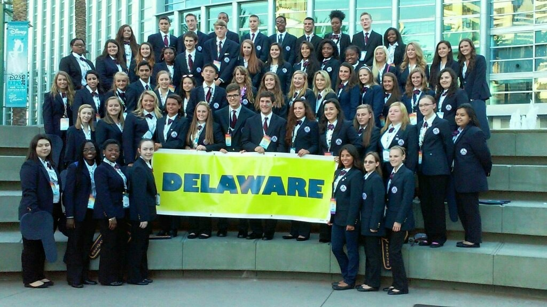
On June 24 - 27, over 81 students and advisors from across the State of Delaware attended the 38th annual HOSA-Future Health Professionals National Leadership Conference in Anaheim, California. Delaware students represented the first state in competitive events that included: Medical Math, Physical Therapy, Medical Photography, Dental Science, Dental Terminology, Medical Assisting, Emergency Medical Services, Nursing Assisting, and more.
Delaware HOSA is a Career and Technical Student Organization (CTSO) dedicated to students who are interested in pursuing their future in a career in healthcare. Through HOSA-Future Health Professionals, members have the opportunity to participate in career focused competitive events, take part in community service work, and become leaders for the organization in their school, state, and at the national level. HOSA-Future Health Professionals incorporates curricular and co-curricular experiences to emphasize the importance of knowledge, leadership, skill development, and teamwork.
As part of the National competitive events, the following students were recognized:
Dental Terminology
Abigail Adams from Sussex Technical High School-Gold Medal Winner
Kaitlyn Neibert from Sussex Technical High School – 6th place
Jennifer Linares from Sussex Technical High School – 8th place

Health Career Display
Lauren Rentz- POLYTECH High School-Gold Medal Winner
Lauren Lee- POLYTECH High School-Gold Medal Winner
Dental Science
Hiten Patel from Sussex Technical High School-Gold Medal Winner
Thomas (TJ) Pinto from Sussex Technical High School-Silver Medal Winner
Emergency Medical Technician
Shawna Killen from St. Georges Technical High School – 10th place team
Jazlyn Washington from St. Georges Technical High School -10th place team
Nursing Assisting
Renee Adams from Sussex Technical High School – 8th place

A list of all national finalists can be found online at: http://nlc.hosa.org/sites/default/files/Sec2015Winners.pdf. To learn more about Delaware HOSA, please visit: www.delawarehosa.org or contact Peg Enslen by phone at: 302.857.3339 or by email at: peggy.enslen@doe.k12.de.us.

